
FURTHER MATHEMATICS
TRIAL EXAMINATION 2
2003
SOLUTIONS

_____________________________________________________________________

Section A - Core – solutions

Question 1

a. The variable x is the independent variable since it represents the amount of rain to have fallen on a particular day. It is reasonable to suggest that the number of accidents would depend on the amount of rain which fell on a day. Hence x is independent and y is dependent. The idea that the amount of rain that fell on a particular day depended on the number of accidents that occurred is ridiculous.
(1 mark)
b. The amount of rain to fall is measured in millimeters and hence is on a continuous scale since you could have 4 ml or 4.28 ml or 4.287586 ml and so on.
The number of accidents that occur can only be a whole number and hence the variable y is discrete.
(1 mark)
c. It would have been appropriate to have tried a log x transformation. (1 mark)

d.
x | 15 | 19
 | 0.07 | 0.05
y | 46 | 51
(1 mark)
e.
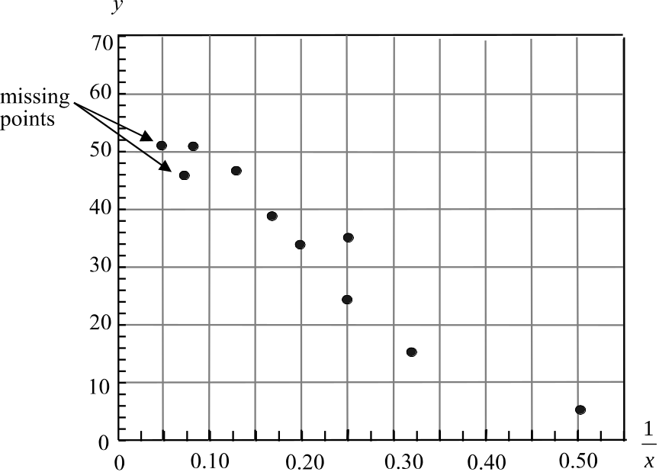

(1 mark)

f. 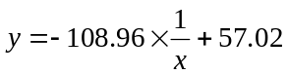
When 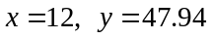
Rounding off, we would expect 48 accidents requiring a tow truck in metropolitan Melbourne on a day when there had been 12 ml of rain.
(1 mark)

g. i. We have
When 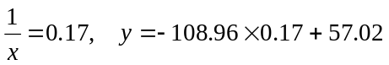
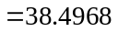 (1 mark)
The residual value is therefore 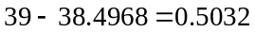
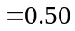correct to 2 decimal places
(1 mark)

ii. So the missing point is 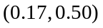.

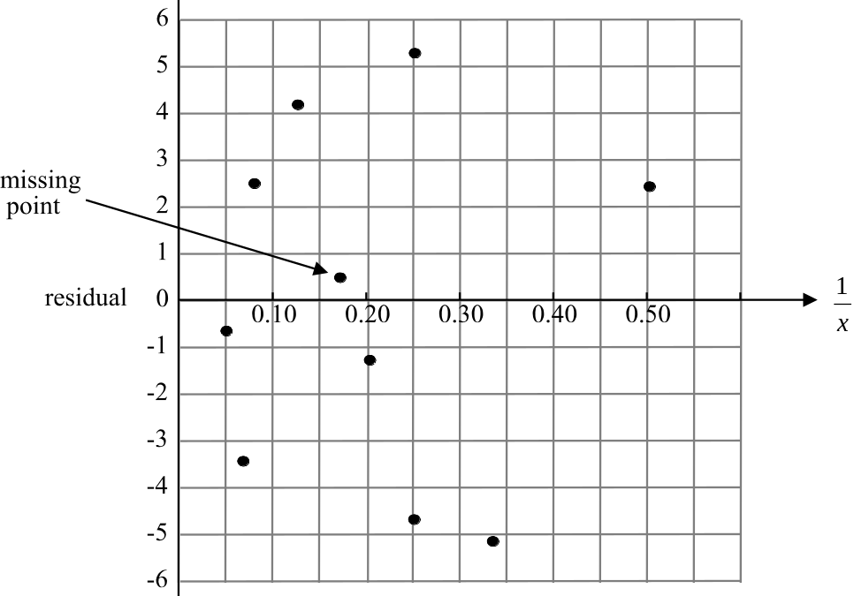

(1 mark)

- We can be fairly comfortable that the transformation has been able to linearise the plot of the original data. This is because the residual plot shows no pattern. It appears to be a random collection of points scattered on both sides of the axis.
(1 mark)

Question 2

a. Find the median number of accidents for July, August, September, October and November. Record this number for the month of September. Find the median number of accidents for August, September, October, November and December. Record this number for the month of October.
Note that 5-moving medians cannot be found for November or December since neither has 2 points to the right of them.

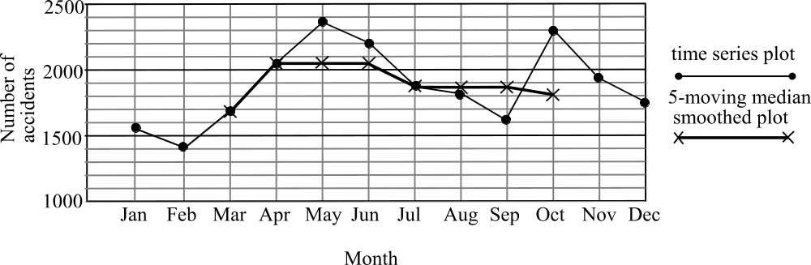

(1 mark) for September point
(1 mark) for October point

b. i. Average = 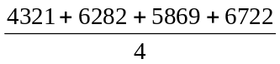
= 5799 to the nearest whole number
(1 mark)

ii. seasonal index for spring in Year 1
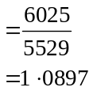
(1 mark)

iii. seasonal index for spring for all three years
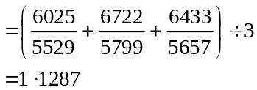
to 4 decimal places
(1 mark)
Total 15 marks

Section B

Module 1: Number patterns and applications

Question 1

a. At the start of day 1 there were 4500 litres.
At the start of day 2 there were 4490 litres.
At the start of day 3 there were 4480 litres.
At the start of day 4 there were 4470 litres.
At the start of day 5 there were 4460 litres.
(1 mark)

b. The amount of water in the tank, 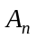, at the start of the n th day of rationing forms an arithmetic sequence with 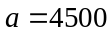 and 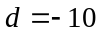. The general form of an arithmetic sequence is 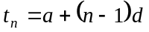.
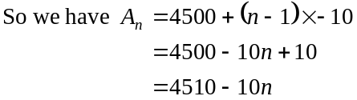
(1 mark)

c. From part b., we have
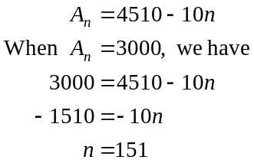
At the start of the 151st day of rationing the amount of water would be 3000 litres.
(1 mark)

Question 2

For the ratio 2:11, there are a total of 13 parts. Two of these parts represent 4500 litres. So one of these parts represents 2250 litres. (1 mark)
So 13 parts represent 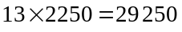. The capacity of the tank is 29 250 litres.
(1 mark)

Question 3

a. The amount of water allowed to be used from the back-up tank each day forms a geometric sequence with
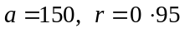
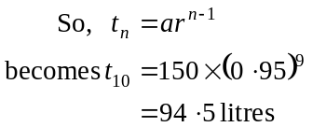
(1 mark)
b. Now, 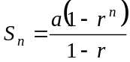 (1 mark)
So, 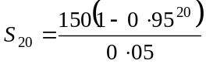
= 1925
So 1925 litres of water (to the nearest litre) would have been used. (1 mark)

c. Now the sum of an infinite number of terms in this geometric sequence is given by 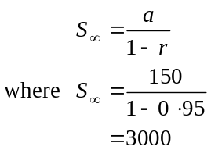
(1 mark)
(1 mark)
So only 3000 litres would be used and hence the back-up tank, which contains 3700 litres would never run out of water.
(1 mark)

Question 4

a. The amount of water added to the tank each week is 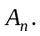 (1 mark)
That is, whatever is in the tank at the start of the week is the amount that is added to the tank. So, at the start of the next week, the 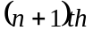 week, the amount of water is twice what was in the tank at the start of last week minus the amount that was used (i.e. 980 litres).

b. i. We have 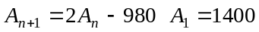
Now given that for
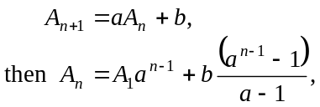
we have,
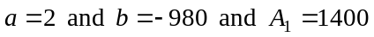.
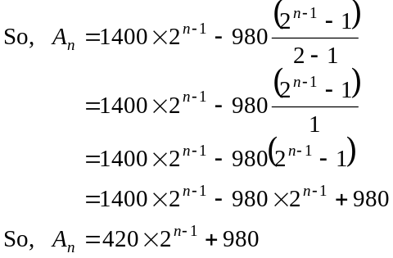
(1 mark)
(1 mark)
which is our expression for in terms of n.
ii. Now, 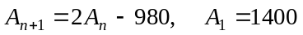
gives 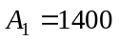
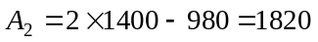
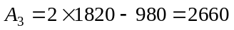
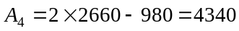
Also, 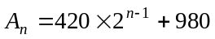
So,
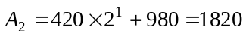
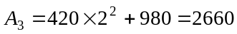
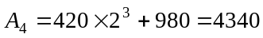 (1 mark)
Have verified for 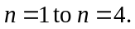
Total 15 marks

Module 2: Geometry and trigonometry

Question 1
- In ΔABC, we have
(1 mark)
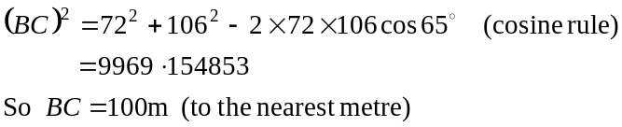
(1 mark)

- “Hence” means use what you’ve just found.

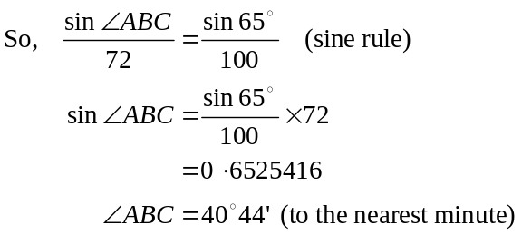
(1 mark)
(1 mark)
- Area of triangle 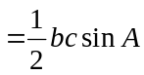 (from the formulae sheet)
Area 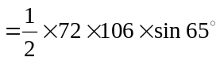 (1 mark)
= 3458 square metres (to the nearest square metre) (1 mark)
Note – if there is a choice, always use values which are given in the question rather than ones which you have calculated.

Question 2
- 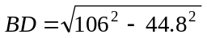 (Pythagoras Theorem)
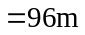 to the nearest metre
(1 mark)
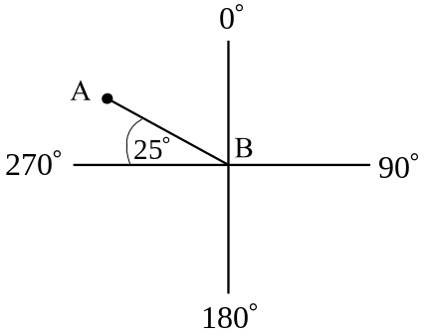
- In
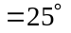
(1 mark)

So the bearing of A from B is
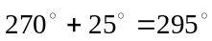. (1 mark)

c. The actual area of Emilio’s land was 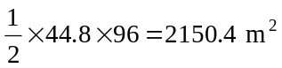. (1 mark)
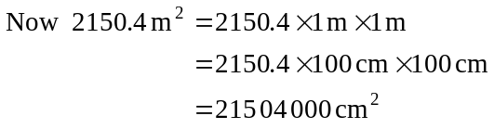
The ratio of the area on the diagram to the actual area on the ground is
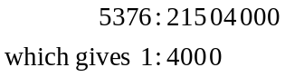
(1 mark)
Question 3
- Consider ΔABD and ΔBEF. These two triangles are similar since 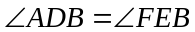 (both right angles) and 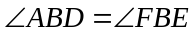 (shared angle) and hence the third angle in each triangle, namely 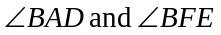 must be equal since angles in a triangle add up to 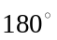. (1 mark) for justification of similar triangles
Draw the two triangles in corresponding positions
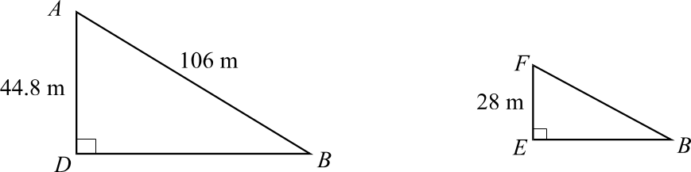

Because the triangles are similar, their corresponding sidelengths are proportional.
Method 1 - using the answer to Question 2 part a..
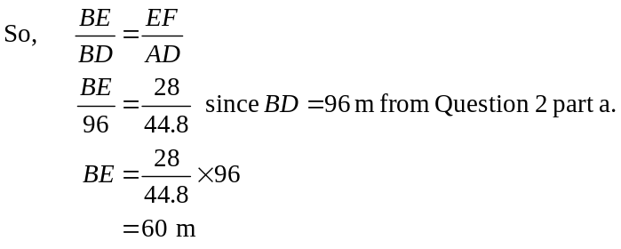
(1 mark)
So the length of Emilio’s new street frontage is given by
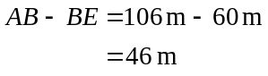
(1 mark)

Method 2 – "otherwise"
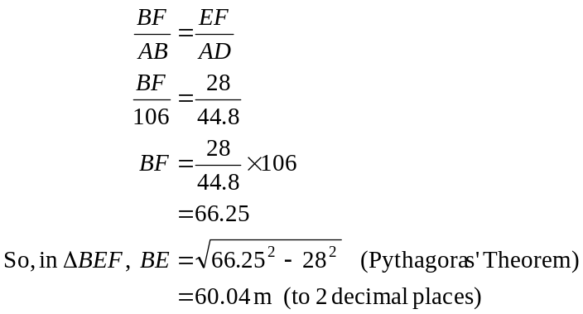
(1 mark)
So the length of Emilio’s new street frontage is given by
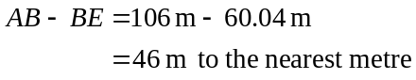
(1 mark)
- The ratio of the sidelengths of the boundary of Teresa’s block compared to Emilio’s original block ABD is 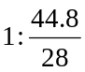 which gives 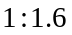. (from part a.)
Hence the ratio of the areas is 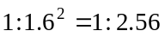. (1 mark)
Note that whilst you were told not to evaluate the areas of any triangles to complete this question, if you have time, you can (and should) use the method of calculating areas to check your answer.
Total 15 marks
Module 3: Graphs and relations.

Question 1
- From the graph, we see that the line is horizontal between 12 – 1 pm, which would have been lunch, and between 3 – 5 pm when he would have been at the seminar. When the line is horizontal the junior solicitor is not charging out his time.
(1 mark)
- By 12 noon the junior solicitor had charged out a total of $800. After that he charged out another 3 hours at $200 per hour. In total for the day he charged out $1400.
(1 mark)
- If he started at 8 am and finished at 6 pm and had no time when he wasn’t charging out then he would have charged out 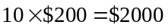.
(1 mark)
- The straight line segments other than the horizontal segments have the same gradient of 200 because the junior solicitor is charging out at $200 per hour, that is, he is charging at a constant rate.
(1 mark)

Question 2
- i. They have the same gradient.
(1 mark)
  - The gradient is – 1. Each of the lines slope up to the left hence the gradient is negative. Each line rises as much as it “runs”. So the gradient is 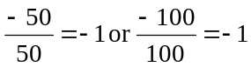. (1 mark)
- i.
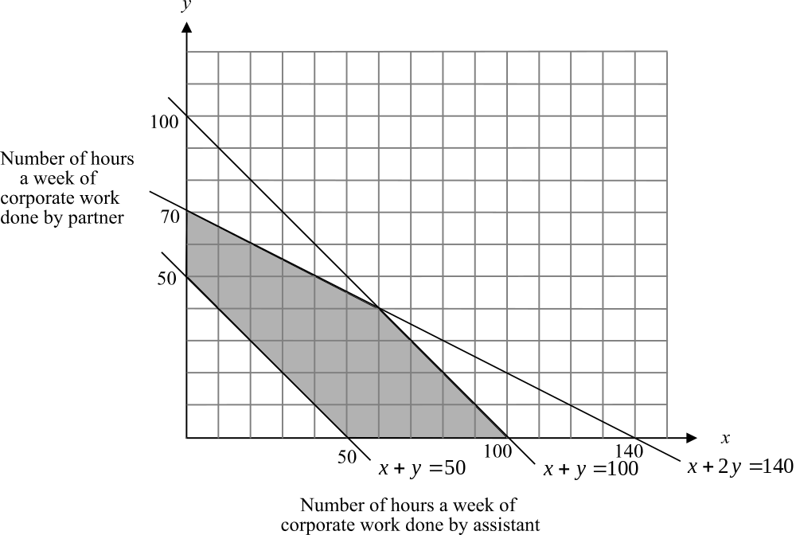

The equation 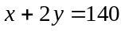 has an x-intercept of 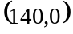 and a y-intercept of 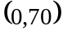. (1 mark)
  - The feasible region is shaded and the boundaries are included. (1 mark)
c. 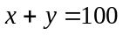 - (A)
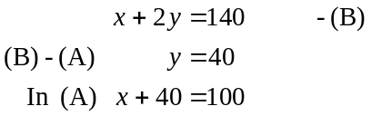
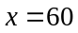 The solution is (60,40). (1 mark)
d. i. 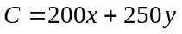 (1 mark)
- The corner points of the region are given below:
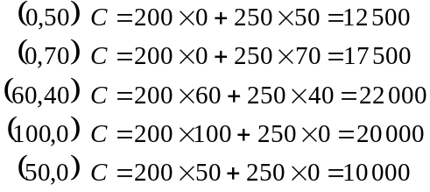
So the maximum amount that the department can charge for the corporate work it does in a week is $22 000. (1 mark) for corner points
(1 mark) for correct calculation of $22 000
e.
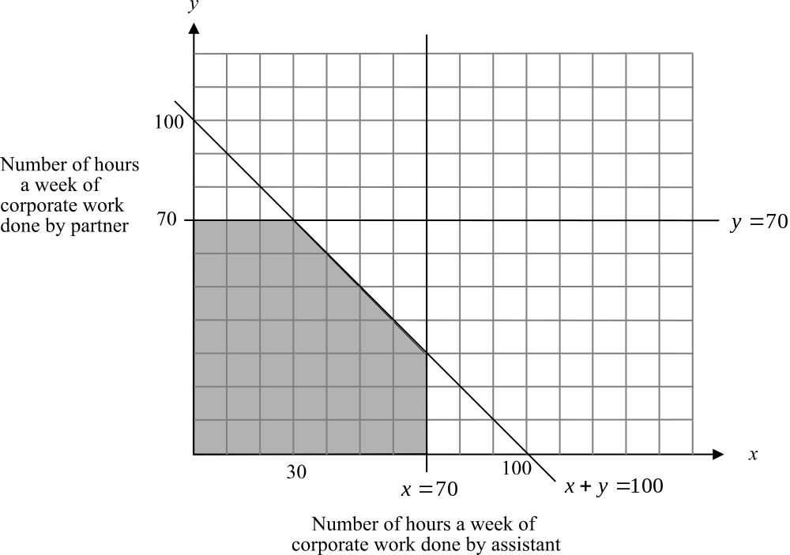

(1 mark) for graph
The corner points are:
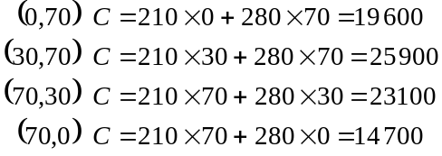
(1 mark) for corner points
The maximum amount that the department can now charge for corporate work done in a week is $25 900 which is an increase of $25 900 - $22 000 = $3900 per week.
(1 mark)
Total 15 marks

Module 4: Business-related mathematics

Question 1

- 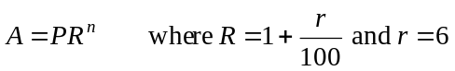
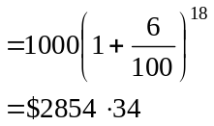
(1 mark)
- The simple interest earned would have been
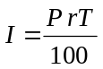
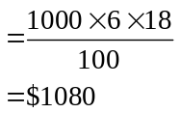
After 18 years the investment would have been worth 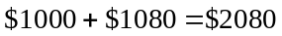.
(1 mark)
- 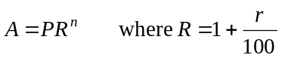 (1 mark)
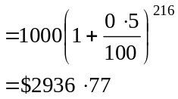
(1 mark)
Note that the period is 1 month and the interest rate per month is 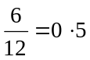.
Also there are 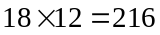 periods over the 18 years.
Note that the interest rate per quarter is
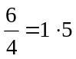
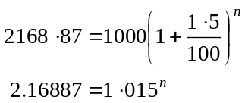
(1 mark)
Method 1 – trial and error
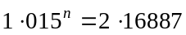
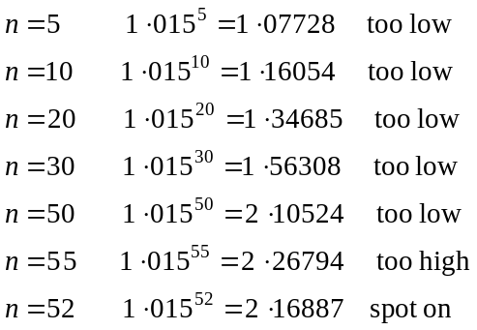
So 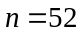 and therefore the amount in the account is $2168.87 after 52 quarters or 13 years. (1 mark)

Method 2 – using logs
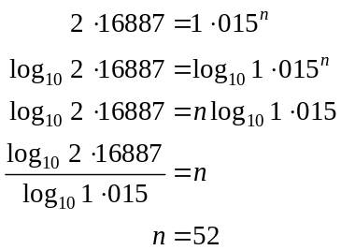
So and therefore the amount in the account is $2168.87 after 52 quarters or 13 years.
(1 mark)

Question 2

- 16% of $32 000 = $5120 and this is the amount that the car depreciates by each year. Now, 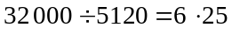. So it takes 6.25 years for the car to have a book value of zero.
(1 mark)

- i. In one year the car would depreciate 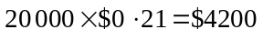. Now 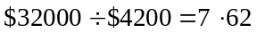 (correct to 2 decimal places). It would take 7.62 years.
(1 mark)

  - The car depreciates at $4200 per year. This gives an annual flat rate of depreciation of 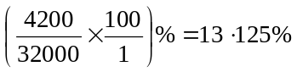.
(1 mark)

Question 3

- On 31-3-03 the interest charge is given by 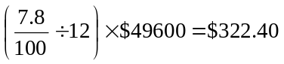.
On 31-3-03 the amount owing is 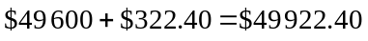. (1 mark)
On 10-4-03 the amount owing is 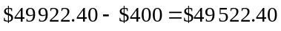.
On 30-4-03 the interest charged is given by 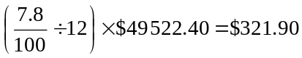.
(1 mark)

- i. Q is the amount paid back per period which in this case is per month. So 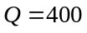.
(1 mark)

  - 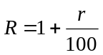 and r in this case is 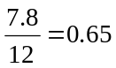.
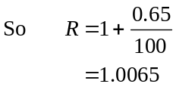
(1 mark)

- We require 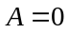 for the loan to be repaid.
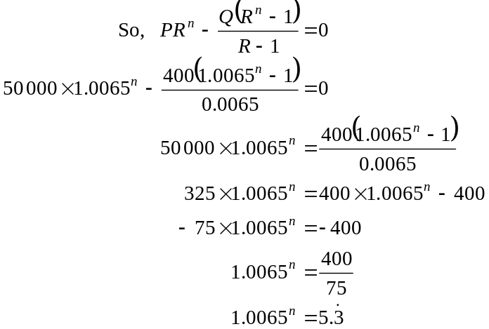
(1 mark)
Method 1 – trial and error
(Note – this method can be employed earlier if desired)
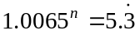
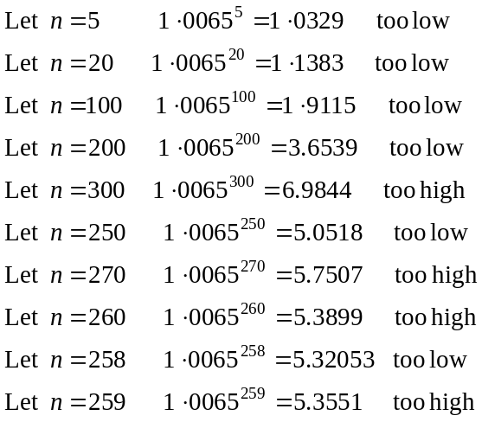
So the value of n is closer to 258. The number of years is 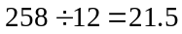.
(1 mark)
Method 2 – using logs
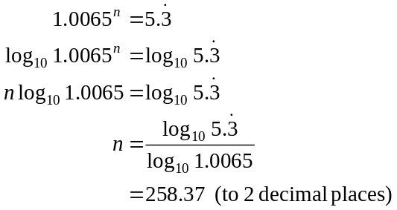
The number of years is 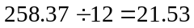 or 21.5 years (correct to 1 decimal place).
(1 mark)

Total 15 marks
Module 5: Networks and business mathematics

Question 1

a. A planar graph is a graph that can be drawn so that the edges have no intersections except at the vertices. The edge joining vertices H and D crosses the edge joining vertices E and J. To redraw one of these edges, say EJ, so that it no longer crossed would still involve crossing other edges, say CD. So, the graph is not planar.
(1 mark)
b. The shortest path is ACEH, which is a total distance of 390m.
(1 mark)
c. A person can start at site A and visit each site just once before returning to site A. This is called a Hamiltonian circuit. One such circuit would be ABFGIHKJEDCA. Another would be ACDJEHKIGFBA. Others exist as well.
(1 mark)
d. We are looking for an Euler circuit and there is a quick test for this. If the graph has all its vertices with even degrees then it will have an Euler circuit. Since vertices B, F, G, I, K and E are all of odd degree the graph does not have an Euler circuit.
(1 mark)
e. Start with the edge joining G and H since it has the least distance. Then choose edge HK since it has the next least distance. Then choose GI, then FG, then EF, then CE, then CA, then AB, then ED, then HJ.
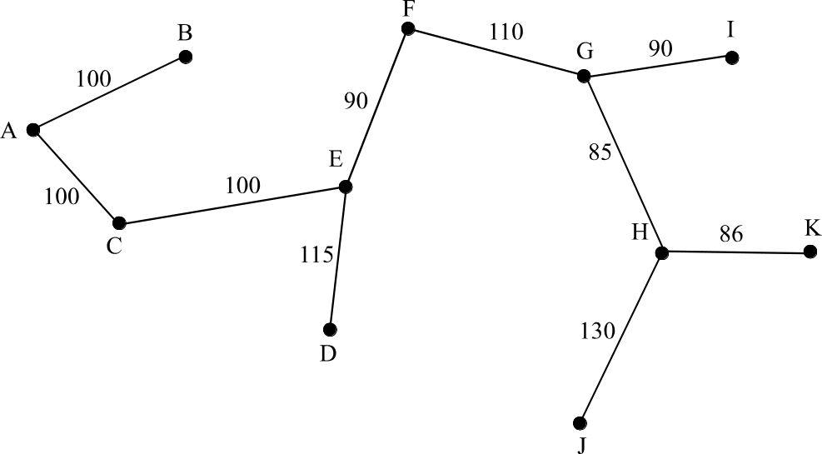

(1mark) for diagram
The total minimum distance is 1006m. (1 mark)

Question 2

a. The capacity of the cut is 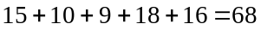. Note that the edge from D to E is directed from the “K” side of the cut to the “A” side of the cut. All the other edges, which are cut, are directed from the “A” side to the “K” side. Since the graph is directed from A to K, the capacity of any cut takes into account only edges directed from A to K. Hence we ignore the DE edge.
(1 mark)

b. We need to find the cut with the minimum flow. This involves trial and error. The cut with minimum flow is shown on the diagram below.
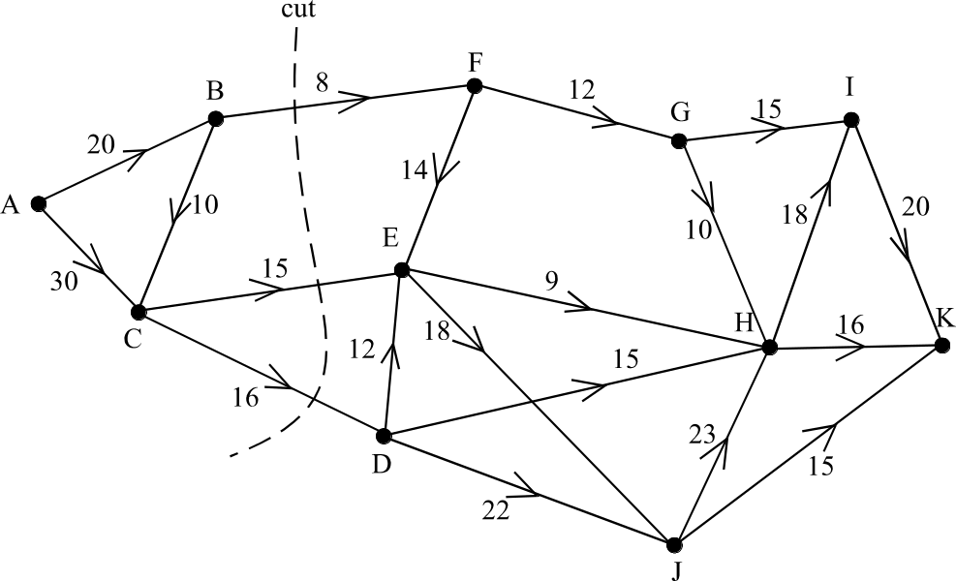

(1 mark) showing cut
The capacity of this cut is 39 and so the maximum number of staff and students who can do this special tour is 39.
(1 mark)

Question 3

a. The predecessor of step E is step B. (1 mark)
The predecessors of step H are steps D and E. (1 mark)

b. On the network below on each node are two numbers. The first is the earliest start time, and the second is the latest start time.
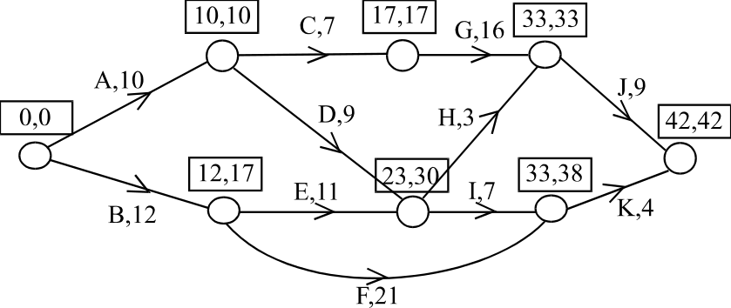

The earliest start time for K is 33 days. (1 mark)
The latest start time for D is 21 days. (1 mark)

c. The shortest period of time is the time taken along the critical path A, C, G, J. This period is 42 days.
(1 mark)
d. Any of the 4 steps on the critical path, that is A, C, G or J since the time taken to complete each of them is critical to the completion of all the steps. (1 mark)
Total 15 marks

